Ballan Cricket Club Annual Report 2022/23

President's Report
This is my first President’s Report for the Ballan Cricket Club. Unfortunately, we were heavily impacted during the season by not having any clubrooms or change rooms – for some of us it was a trip down memory lane getting changed in cars and having refreshments out of the car boot. Also, the weather did not help and Covid was still being a nuisance….
But we survived, bigger and better, our junior numbers were up (the Blasters and an extra Under 11 team). A special thanks to Jenny (and her helpers) for taking on the Junior coaching of our little ones. Our bigger little ones 13’s, 15’s and 17’s were ably coached by Mac, Summer, Jack and Ben. Thank you so much guys.
Whilst on thanking people, Mark and Max, you guys enabled us to get sides on the park and make training something I looked forward to, especially Max’s speeches – thank you.
To the Committee – every club has a committee, I think ours is one of the best. Every meeting was almost 100% attended and everyone had some input at some stage. It makes the President’s job a lot easier so thank you. Special thanks to Bronwen (as Secretary) and Jack (as Treasurer) – two very important and time-consuming jobs. Unfortunately a few of our Committee members won’t be with us next year. But that opens up vacancies for anybody interested in helping our Club.
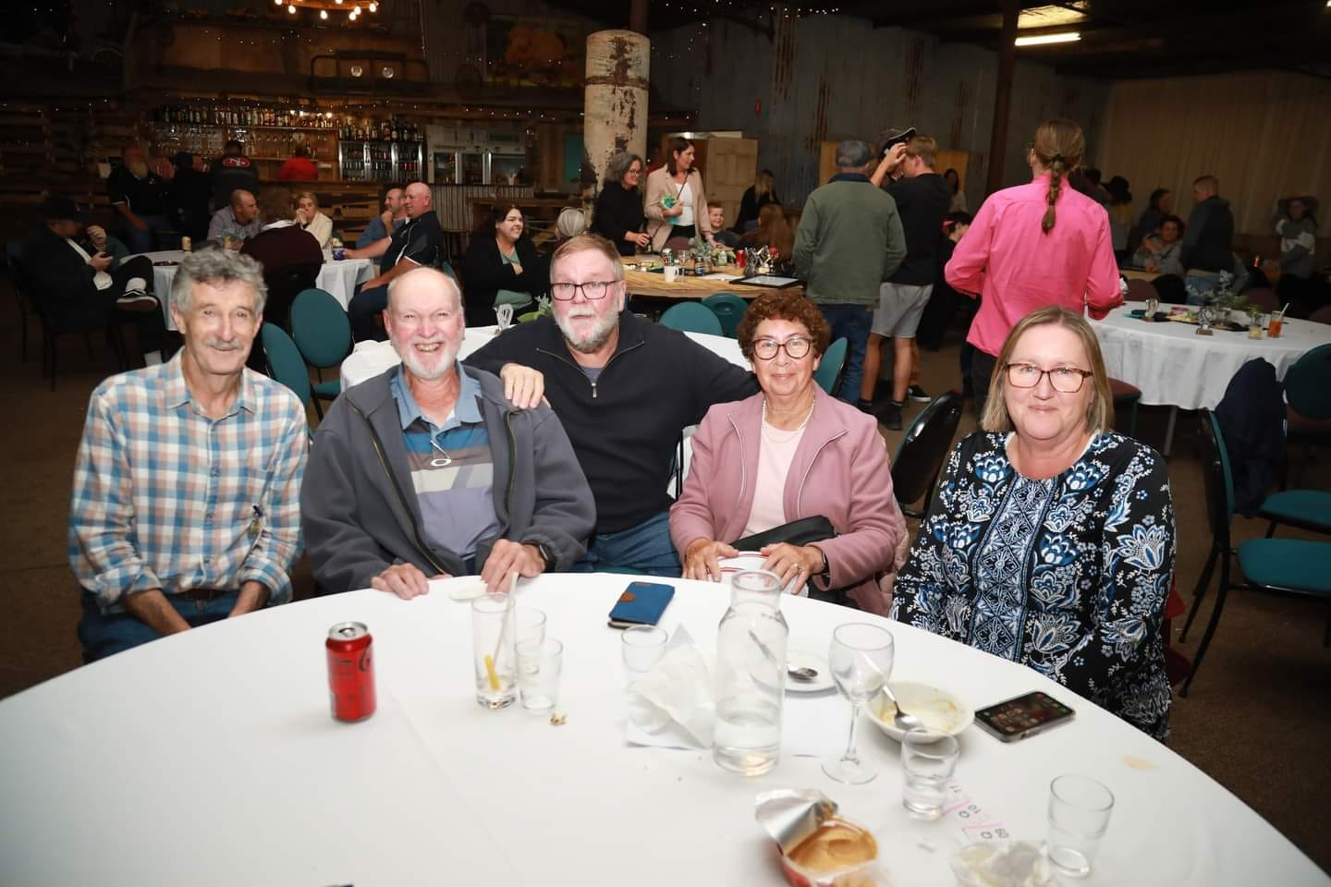
To the parents of our juniors and partners of our senior players - thank you for your support during the season. As I mentioned during the Presentation Night you are all coaches, cooks, chauffeurs and cheer squad. Thank you all for your year as well.
Figure 1: Chris Mullane, John Costello, David Leach, Pat Costello, Steph Leach
To our senior players who have stuck with us, and committed to playing and training, thank you all.
Unfortunately, by not having any clubrooms we have taken a bit of a hit financially. But by having hard workers and loyal sponsors we survived. We applied for many grants and due to some successful results, we will be trying to keep next year’s fees the same as this year.
So, what’s in store for the Ballan Cricket Club – well it’s all positive. The new rooms “should” be finished, the new nets are already being used and hopefully the new electronic scoreboard will be installed. So, we are hoping for an exciting season ahead.
Looking forward to seeing everyone in Season 2023/24.

David Leach
President

Committee Members for 2022/23
David Leach (President, Recreation Reserve)
Noel Heafield (Vice President)
Jack McGregor (Treasurer)
Bronwen Davenport (Secretary)
Anthony McIlwaine (Junior Coordinator)
Todd Britt (Child Safety Officer)
Ben Loughnane (Uniform Officer)
Bronwen Davenport (Female Cricket Officer)
David Leach (Ballan Recreation Reserve Representative)
Chris Thom (Website Officer and Club Photographer)
General Members: Mark Kennedy, Hayden Micallef, Mick Loughnane, Stuart Grigg, Glenn Easterbrook, Michael Vallance, Troy Connor
Non-committee Contributors
Jenny Bates – Grants Officer
Saveria Singh - Sponsorship
Kate Grigg - Fundraising

Coaches and Captains
Mark Kennedy - Senior Coach
Hayden Micallef - Senior First XI Captain
Max Burton - Senior Second XI Captain
Ben Loughnane, Jack McGregor U17s coaches
Summer Dehnert - U15s coach
Anthony McIlwaine, Max Burton - U13s coaches
Jenny Bates, Matt Shugg, Marty Phillips, Stuart Grigg, David Leach - U11s coaches
Jenny Bates - Junior Blasters Coordinator

We would also like thank all our other dedicated team and club volunteers such as scorers, team managers, BBQ cooks, bar tenders, raffle sellers, sponsors, and parents, family and friends who provided transport and support to our players, which enabled us to have a successful season.
Maybe you have some idea to make things better or some special skills to offer or would like to try something new. Please contact someone at the club for more information.

Treasurer’s Report

In spite of ongoing lack of clubrooms, were still able to stay afloat with the following fundraisers, grants and sponsors, some Friday night BBQs and of course our player registration fees. Thanks for all your support in these efforts.
Major fundraisers were Bunnings BBQ, Toyota Raffle, Superdraw Raffle, Ballark Gun Shoot and the Presentation Night Raffle
Grants from Moorabool Shire, Cricket Australia Grassroots Fund and the Bendigo Bank allowed us to purchase balls, update our junior cricket kits and other training and game day equipment, laptops for committee members without additional outlay.
Thanks to ongoing sponsors and some new ones.

Ballan Fresh ($1000 total cash + $500 donated goods 2022/23)
Snaith Transport ($500) + Elgas ($300)
3x $500 sponsors: Specialised Fencing; Red Hot Outdoors; Jarmain Fencing; Norstar Steel Recycling; Commercial Hotel; Ballan Plumbing; Modular Interior Linings and $100 - Graze Ballan

Senior Cricket

Ballan entered two teams into the 22/23 season, 2nd Grade Division 1 and 4th Grade competitions. Due to a heavily weather affected first half of the season, lack of consistency and a moving schedule, saw both sides struggle to fill sides throughout the year.
Although both sides missed finals, we saw some brilliant individual performances scattered throughout. Seeing 5+ wicket hauls, centuries, and half centuries, and other strong performances in winning and losing games, as it was only a matter of times before consistent performances would occur.
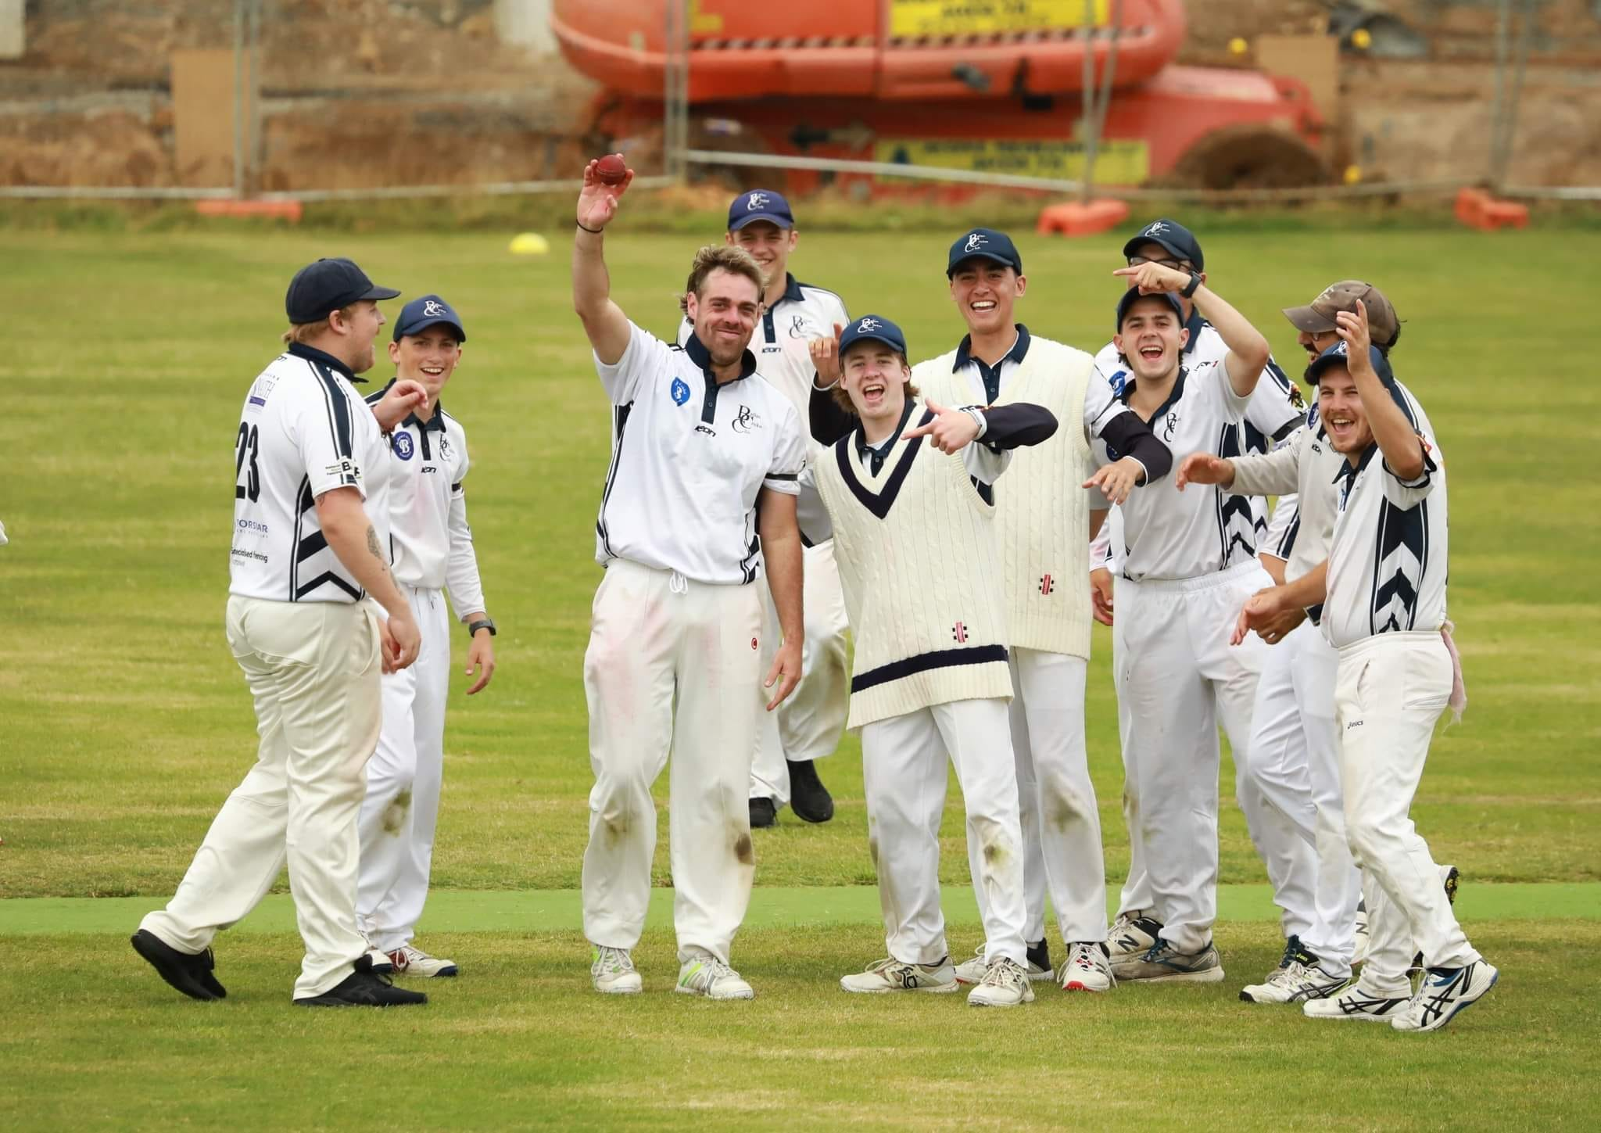
Figure 2: First XI celebrating Captain Hayden Micallef's 5th wicket. He ended the day 6/79
As availability increased with bettering weather and a normal fixture, team performances saw some very impressive wins for the 2nd Grade team, and extremely competitive performances by the 4th grade side resulting in a win in their last match of the season.
Once again, both sides relied heavily on the help of some extremely talented under 17s, and the guidance and commitment of both captains, Hayden Micallef (2nd Grade) and Max Burton (4th Grade), was extremely appreciative. We are looking forward to taking that momentum into the upcoming season.

Team Members 2022/23: Max Burton, , James Childs, Michael Clark, Ben Conroy, John Costello, Summer Dehnert, Heath Doherty,Glenn Easterbrook, David Gardner, Corey Golding, Matt Golding, Jarryd Graham, Stuart Grigg, Kobe Heafield, Noel Heafield, Jake Hotchin, Mark Kennedy, David Leach, Banjo Leahy, Ben Loughnane, Jack McGregor, Christopher Micallef, Hayden Micallef, Elijah Muir, George Muir, Shane Newton, Mick Nolan, Liam O’Connor, Daniel Pascoe, Mackenzie Popple, Evan Shaw, Param Singh, Lachlan Snaith, James Somers, Rodney Sutherland, Chris Thom, Matt Thomas, Jake Wernicke, Michael Vallance

Juniors who played Senior Cricket: Angus Britt, James Burton, Sarah Burton, Eamon Grigg, Jack Jarvis, Ryan Lister, Ned Loft, Elijah Muir, Josh Singh

Junior Cricket
Junior Blasters
Good numbers, 16 kids registered: Paige Skilton, Marshall Cooke, Georgia Shanahan, Noah Kettle, Reilly Grech, Mack Cairns, Angus Dowling, Izak Osborn, Dudley River, Bowie Clark, Alfred Phillips, Charlie Strachan, Emmerson Strachan, Eidee O’Brien, Bonnie O’Brien, Jordy Fenwick,
Ran very well by Jenny, required additional support during the program and were assisted by some parents.
Under 11s
17 players, 2 teams, Junior and Senior.
Kiara Grigg, Bridie Grigg, Ned Conroy, Layla Shugg, Edward Bayard, Katie Bayard,
Rhys Vella, Olivia Dowling, Isaac Kettle, Jamie Jarvis, Oscar Phillips, Jack Mullane, Angus Muldeary, Henry Cairns, Hudson Squires, Jay Fenwick, Jack Leckie
Seniors very competitive team, lots of improvement and positive feedback from the player’s parents. Lots of support for Jenny from multiple families.
Jenny to remain involved, helper parents from this season need to be approached for formal roles next season. Assistant Coaches required working under the guidance of Jenny, potentially Squires/Phillips families.
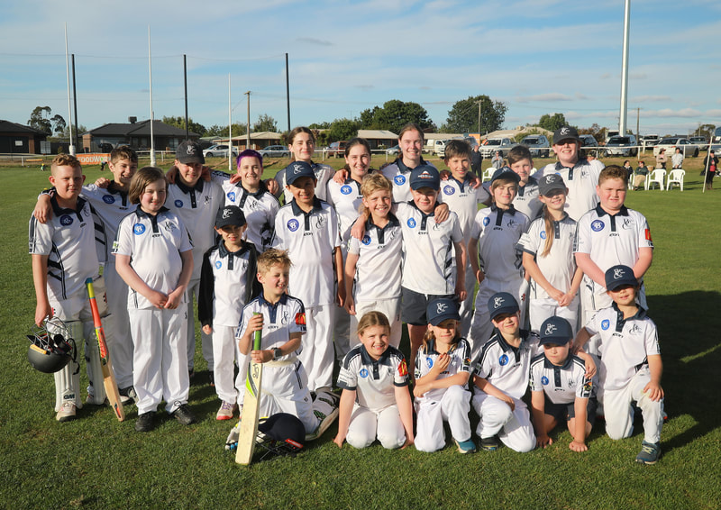
Figure 3: U11s and 13s breakup game December 2022

Under 13s
Team Members: Kori Davenport, Oscar Britt, Clover McIlwaine, Eamon Grigg, Sarah Burton, Jackson Letcher, Mabel Ayres, Mickey Rawlins, Callum Lister, Angus Tranter
10 players initially (1 new to cricket) and then 9 players after a player decided to switch to basketball. Coached by Macca and Max.
A successful year with lots of improvement. Made it to finals for third consecutive year. A happy cohesive team. Did very well in the Hollioake (Div.1) competition in which Ballan has not had a team in for many years.
3 Representative players with the BCA and YPL
7 players from this year’s team to move to U/15s next season, Macca and Max to move with the players.
Coaches required for next season, potentially Shugg/Grigg families. Recommend Spratling (U/13s Div. 2) and elevate stronger U/11s to fill team if required.

Under 15s
4 players, team combined with Brown Hill.C.C and coached by Summer in combined training with Under 13s.
Team members: Jai Singh, James Bayard, Charlotte Wallace, Riley Storer
Not an ideal situation however we were able to get the players a game and keep them at Ballan CC and involved in cricket. Summer did an outstanding job with the players this season.
All 4 players eligible for 15s next season along with graduating 13s.
Mac, Max and Summer wish to coach the 15s next season in U/15 2nd XI.

Under 17s
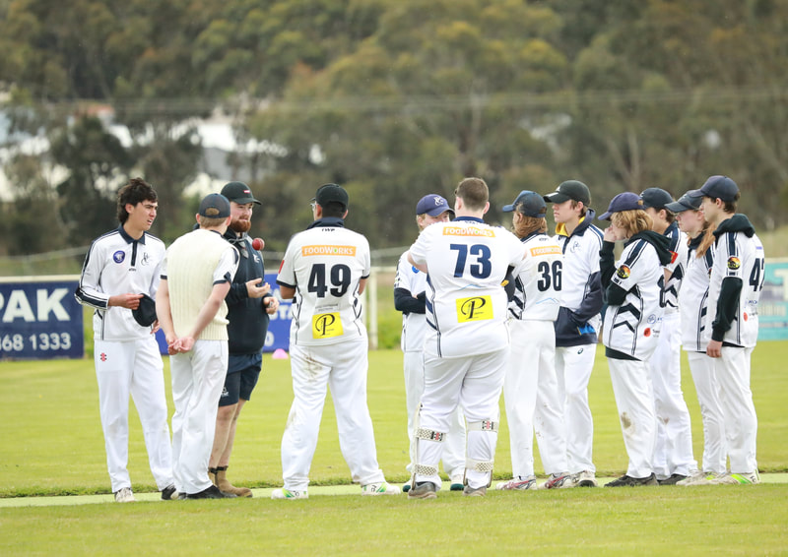
Figure 4: Coach Jack McGregor and the U17s team
11 Players (Including 2 players from Darley CC), coached by Jack and Ben in conjunction with Senior training at times, competitive team that was challenged with injury and player availability at times.
Team Members: Angus Britt, James Burton, Sarah Burton, Jack Jarvis, Ryan Lister, Ned Loft, Clancy Matheson, Elijah Muir, Josh Singh, Jackson Hunter (Darley CC), Max Hoey (Darley CC)

3 players from this year’s team to move to Senior Cricket next season.
2 Representative players, 1 in BCA and 1 YPL player.
Majority of players played senior cricket at some stage throughout the season.
Potentially short of players next season for a full team. Worthwhile gauging early, liaising with BCA and looking for a club to combine with. Recommend U/17s Div. 2 if competition is split.
2022/23 Season will require a Coach(s)

Summary
The major issue next season as always is Coaches. Assistants are required for the 11s with Jenny and Coaches for the 13s and 17s. This needs to be conveyed in all Team Messenger groups. In the near future we need to advertise on the Ballan CC Facebook and then look at specifically asking parents of players, particularly long-term parents at the club to step up to help get our teams on the park.

High Achieving Junior Ballan Cricketers for 2022/23

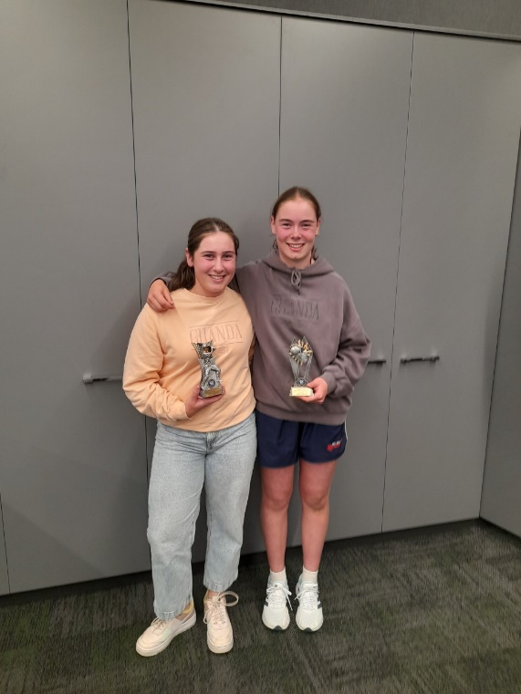
Clover McIlwaine won the Ballarat Cricket Association (BCA)’s U/13 Hollioake Competition’s (First Division) Batting Award for the most runs by an individual throughout the season with 243 runs at an average of 60.75. This was an amazing achievement in a competition predominantly consisting of all male teams, in which Clover opened the batting most weeks for her team.
Figure 5: Clover McIlwaine and Sarah Burton BCA Awards Night 2023
Sarah Burton was named BCA Player of the Series U/14 Girls for her performances representing Ballarat, in the KFC –Western Victoria Girls Cup with 179 runs at an average of 89.5 which included her maiden century and the responsibility of captaining the team.

Along with Kori Davenport, Clover and Sarah also were part of the winning Ballarat team in the Western Victoria Girls U14s Championship.

Ryan Lister, our U/17 and Senior Player, capped off a brilliant all round season placing 3rd in the BCA U/17 Batting Award with 305 runs at an average of 61.00 and 3rd in the Bowling Award with 12 wickets at an average of 11.00 to display his all-round attributes. In the voting for Champion player, Ryan placed 3rd overall with 11 votes. Ryan also enjoyed Representative success playing in the BCA Under 17 Kirton Shield team which defeated GDCA in the final.
Other achievements include:
Kori Davenport, Clover McIlwaine: Sarah Burton: represented the Central Highlands Region at the Cricket Victoria Youth Premier League U15 Female Championships.
Jack Jarvis: selected for the Central Highlands Region Cricket Victoria Youth Premier League U16 Male Championships and U17s Dowling Shield for Footscray but unfortunately injury prevented him playing. He did some assistant coaching however at the YPL tournament.
Kobe Heafield and Heath Doherty: represented the Central Highlands at the U18s division of the Victorian Country Cricket League Championships

Female Cricket
While we weren’t able to get a female only junior team to happen again, we saw great retention with female participation across Blaster, Under 11,13 and 15s team. We had some additional girls start playing with us in the U11s and the Blasters. We also saw the return of former junior Summer Dehnert to the club as a junior coach and play a couple of senior matches. Sarah Burton, Kori Davenport and Clover McIlwaine also represented the BCA at the Western Girls Cup and the Central Highlands U15 Female YPL team at the State Championships in January. Our U13s/15s coach, Macca, also coached at both these tournaments.

Recreation Reserve
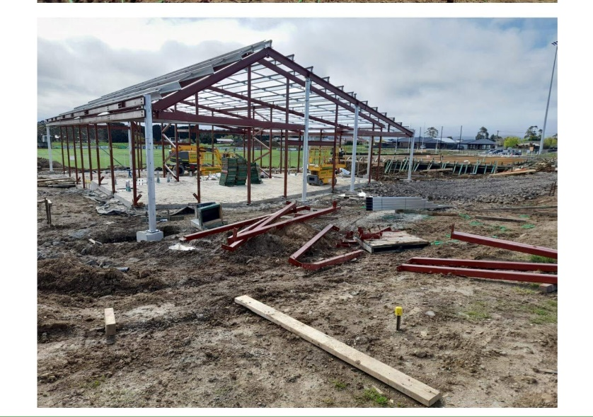
The recreation reserve meetings this year continued to be dominated by the impending new club rooms, hopefully they will be finished for next season. The heavy rainfall over the winter and spring meant lengthy delays. The football club arranged some portable change rooms and toilets and allowed us to use them, meaning we had a relatively normal home and away season. Estimate completion date for change rooms is now May 2023, with the social rooms hopefully August/September. The new nets were completed the week after the season ended. We also assisted in numerous grants to help with the rebuild including new furniture, electronic scoreboard for the ground and a security system.
Figure 6: New club Buildings under construction October, 2022
Presentation Night and Awards

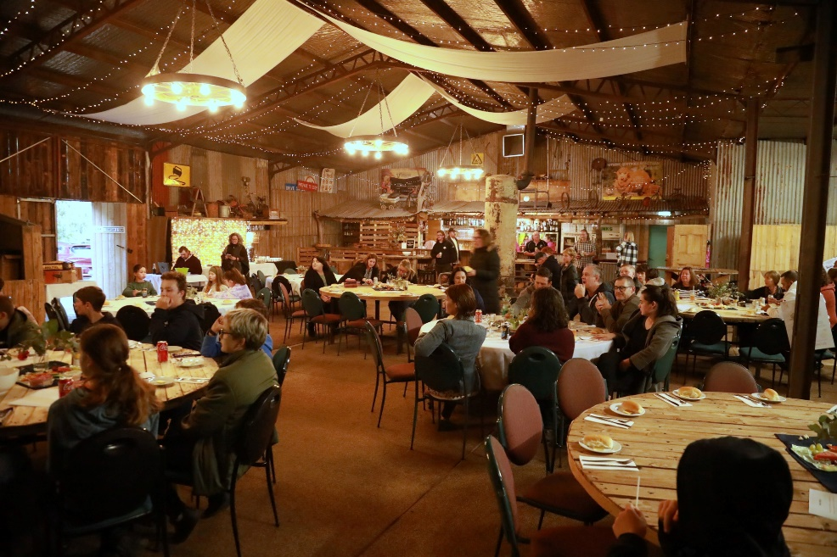
The Ballan Cricket Club gathered at Donegan’s Farm in Gordon to celebrate the 2022/23 season on Friday 31st March. We had nearly 120 people attending our presentation night, with poor weather outside, but a warm fire and great food and atmosphere inside, so appreciate all who could come out. It was again another season of challenges, with a slow start due to high rainfall and also without clubrooms in which to gather, so grateful to all who stuck with us, enabling teams to get on the ground and some excellent cricket played. A highlight of the evening was, after welcoming Mick Nolan back to the club after time away at another club in the BCA First Division, he received his 4th Club Champion Award. Another award was Jack McGregor, our club treasurer getting the Club person of the Year Award, for his tireless work behind the scenes managing our finances, assets and stocks and wise advice to the committee. Thanks to our players and their families for being part of our teams and community. Grateful for all our committee members, coaches and other volunteers that work hard for our club to keep it running. We look forward to seeing you all again next season.
Figure 7:2022/23 Presentation Night at Donegan's Farm, Gordon
2022/23 Season Awards
Leigh Conroy Memorial Best Club Person Award: Jack McGregor
Seniors 1st XI
McConnell Family Club Champion Mick Nolan - 587 Points
Batting Award Mick Nolan - 447 Runs @ 55.88
Bowling Award Kobe Heafield - 12 Wickets@12.75
Most Consistent Jack Jarvis
Fielding Award Jack Jarvis
Best Team Player Matthew Golding
Seniors 2nd XI
Chris Mullane Cricketer of the year David Leach - 418 Points
Batting Award (Most Runs) Param Singh - 244 Runs @ 40.67
Batting Award (Best Average) David Leach - 58.25
Bowling Award Jake Wernicke - 11 Wickets@20.91
Captains Award Michael Vallance
Team Player Award Glenn Easterbrook
Under 17’s
Cricketer of the year Ryan Lister - 646 Points
Batting Award Ryan Lister - 305 Runs @ 61.00
Bowling Award Ryan Lister - 12 Wickets @11.00
Fielding Award Jack Jarvis
Most Consistent Elijah Muir
Coaches Award Angus Britt
Coaches Award James Burton
Most Improved Josh Singh
Significant achievements Seniors and U/17s
5 wickets in an innings
Ryan Lister 2022/23 Ballan U/17, Round. 5 vs Wendouree White 8.1/3/5/11
Hayden Micallef 2023/23 Ballan 1st XI, Round. 13 vs Golden Point 27.4/7/6/79
Jake Wernicke 2022/23 Ballan 2nd XI, Round. 10 vs Ballarat Fire Brigade 6/0/5/34
100s
Mick Nolan 109 2nd Grade. 4/12/22 Round 2 v Dunnstown at Dunnstown
Ryan Lister 101 U17s, 10/12/22 Round 5 against Wendouree White at Ballan
Param Singh 128 not 4th Grade, 11/2/23 Round 12 v Coronet City at Ballan.
Ryan Lister 100 not out, 4th Grade, 11/3/23 Round 14 against Golden Point at Ballan.

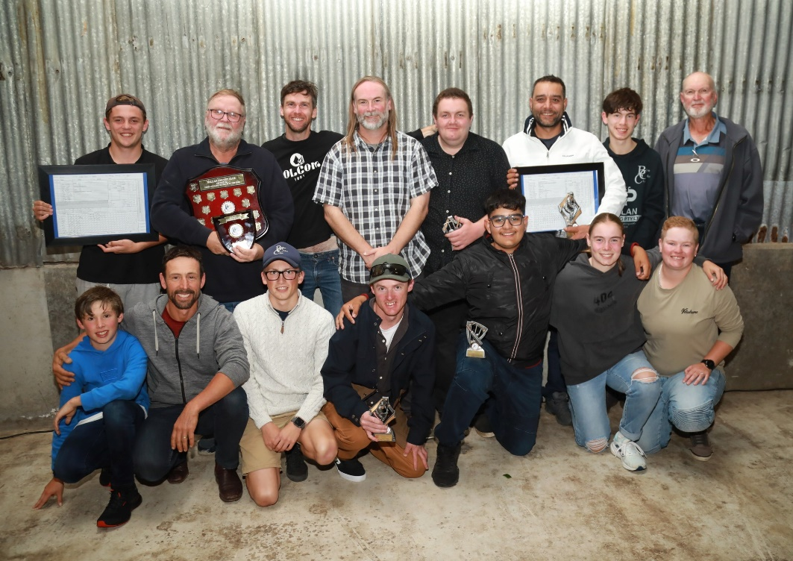
Figure 8: 2nd XI players at Presentation Night
Under 15’s
Team Spirit Jai Singh
Most Consistent Riley Storer
Coaches Award James Bayard
Most Improved Charlotte Wallace
Under 13’s
Team Spirit Oscar Britt
Encouragement Mickey Rawlins
Participation Awards: Kori Davenport, Oscar Britt, Clover McIlwaine, Eamon Grigg, Sarah Burton, Jackson Letcher, Mabel Ayres, Mickey Rawlins, Callum Lister

Under 11s Participation Awards
Kiara Grigg, Bridie Grigg, Ned Conroy, Layla Shugg, Edward Bayard, Katie Bayard,
Rhys Vella, Olivia Dowling, Isaac Kettle, Jamie Jarvis, Oscar Phillips, Jack Mullane, Angus Muldeary, Henry Cairns, Hudson Squires, Jay Fenwick, Jack Leckie

The following businesses helped us with prizes and gifts on the night. Ballan Fresh, Crossroads Trading, Ballan Bacchus Marsh Vet, Manna Hill Olive Grove, Ballan Dentist, Hank and Heidi, Phoenix Park, Zest Café, Ballan UFS Pharmacy, Ballan Post Office, Enbom Honeys, Skin Inn, True Hardware, St Anne’s winery, Noddy’s Cottage, Joe McFall Real Estate, Hair Retreat, Ballan Butcher, Fabulous Flowers, Regent Cinemas Ballarat, Pancake Kitchen Ballarat, Luna Park, Taco Bill Bacchus Marsh, Melton Reading Cinemas, Bunnings Melton. Please support our local businesses around town and thank them on behalf of the club when you use your prizes.

BALLAN CRICKET CLUB PARTICIPATION DATA
(Supplied to the Stake Advisory Group – Ballan Recreation Reserve Redevelopment April 2022)
Update for 2022/23 Season

2022/23 Participation at Ballan Cricket Club

Sector | Male | Female | Other
Juniors | 32 | 9 | 1
Junior Blasters | 11 | 5
Seniors | 36 | 1
Volunteers (committee) | 14 | 3
Volunteers (coaching staff) | 8 | 2

2021/22 Participation at Ballan Cricket Club
Sector | Male | Female
Juniors | 34 | 10
Junior Blasters | 11 | 4
Seniors | 34 | 1
Volunteers (committee) | 9 | 3
Volunteers (coaching staff) | 7 | 1

2020/21 Participation at Ballan Cricket Club
Sector | Male | Female
Juniors | 37 | 6
Junior Blasters | 5 | 2
Seniors | 32 | 0
Volunteers (committee) | 12 | 1
Volunteers (coaching staff) | 6 | 1

2019/20 Participation at Ballan Cricket Club
Sector | Male | Female
Juniors | 41 | 4
Junior Blasters | 11 | 6
Seniors | 38 | 0
Volunteers (committee) | 15 | 1
Volunteers (coaching staff) | 10 | 0

2018/19 Participation at Ballan Cricket Club
Sector | Male | Female
Juniors | 36 | 8
Junior Blasters | 12 | 5
Seniors* | 59 | 0
Volunteers (committee) | 15 | 2
Volunteers (coaching staff) | 9 | 1
* Please note there were 3 x senior teams this year

2017/18 Participation at Ballan Cricket Club
Sector | Male | Female
Juniors | 41 | 6
Junior Blasters | 12 | 12
Seniors | 26 | 0
Volunteers (committee) | 13 | 0
Volunteers (coaching staff) | 8 | 1

